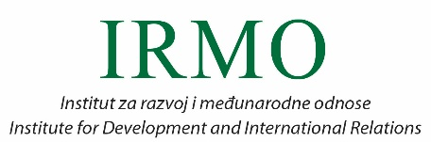

POLO Cro-28 International Conference

THE CHALLENGES OF IMPLEMENTING EU POLICIES IN CROATIA AND OTHER NEW MEMBER STATES

9th July 2018 (Monday)

Auditorium of the Rectorate Building, University of Zagreb
Trg Hrvatske Republike 14.

Registration form

Name:
Surname:
E-mail:
Institution:
Function:

Please send your registration form by the 4thof July 2018 (Wednesday) to: ana@irmo.hr

